Newtown’s Handwriting Teaching Guide

Through daily teaching and practice of handwriting we ensure that children develop sufficient handwriting skills.
We make the physical process of writing – handwriting – enjoyable from the start, so children see themselves as ‘writers’. We use mnemonics – memory pictures – to help children visualise the letter or join before they write it down. Children need to practise handwriting under the guidance of a teacher so they do not develop habits that will be difficult to undo later.
We don’t ask children to copy letters or words. We need their attention to be focused on their own formation of letters and joins.
We teach handwriting daily in Reception to Year 4. Handwriting is taught in Year 5 and 6 three times a week.
From Stage 2, we use the RWI handwriting videos to support our teaching. This is complemented by teacher modelling and opportunities for independent practice. Based on the teacher’s assessment for learning, the structure will follow this sequence:
- Day 1: Use of RWI handwriting video
- Day 2: Teacher modelling and practice using the blueprint lesson plan
- Day 3: Independent practice, review of previous learnt letters and joins. Ensure target support on identified children.

Where should children sit to write?
First, we arrange tables and chairs so all children can clearly see the board/whiteboard. Children practise sitting comfortably at a table to write. This is much more comfortable than sitting cross-legged, hunched over a whiteboard.
Handwriting position
We teach children that when we say ‘perfect handwriting position’ they quickly:
• put two feet on the floor
• push their bottom to the back of their chair
• tuck their chair under the table
• hold their pencil in a tripod grip
• place their other hand on their book or paper, so it doesn’t move around.
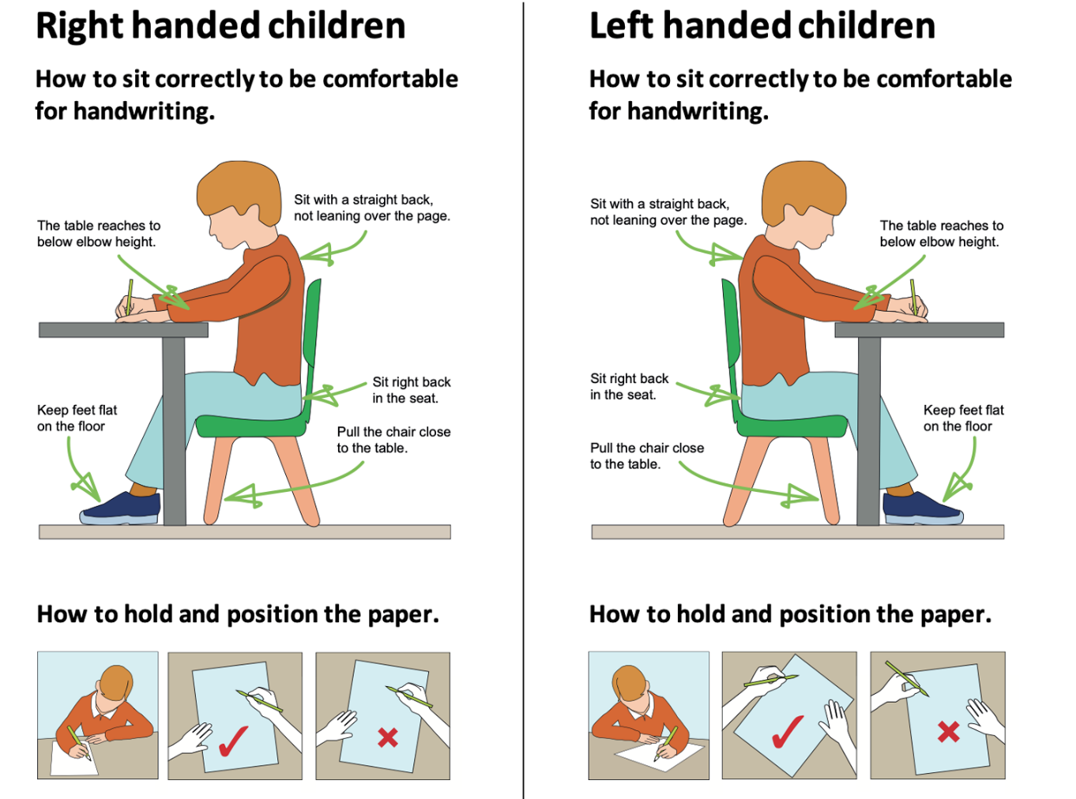

What should children use to write?
In EYFS, children use a chunky triangular HB pencil. From KS1, children use a standard HB pencil. We teach children how to hold a pencil in a tripod grip. We check their grip at the start of every handwriting lesson – and in all other writing activities. Some children benefit from using a triangular rubber grip on their pencil. Pencils are sharpened ready for the handwriting lesson.
When in KS2 teachers assess that children are competent at joined handwriting they should be allowed to use a black handwriting pen.
Pencil Grip
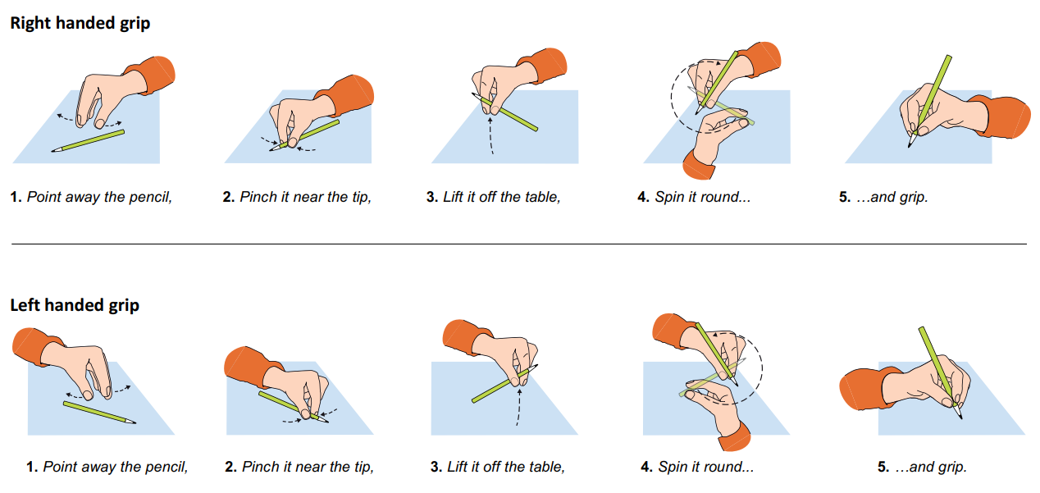

What should children write on?
For Stage 1, children write in an unlined exercise book. This is so they can focus on correct letter formation (Reception)
For Stage 2, children write on highlighted yellow paper which is 15mm wide. (Year one)
For Stage 3, children write on highlighted yellow paper which is 10mm wide. (Year two onwards)
For Stage 4, children write in 8mm-lines.

How can I support children who are left-handed?
This how you can help children who are left-handed: Give them more space to write by placing them to the left of a child who is right-handed so their arms don’t nudge each other, show them how to slant their paper to the right so they can see more of their writing and show them how grip the pencil at a slightly higher point so they can see around their fingers.
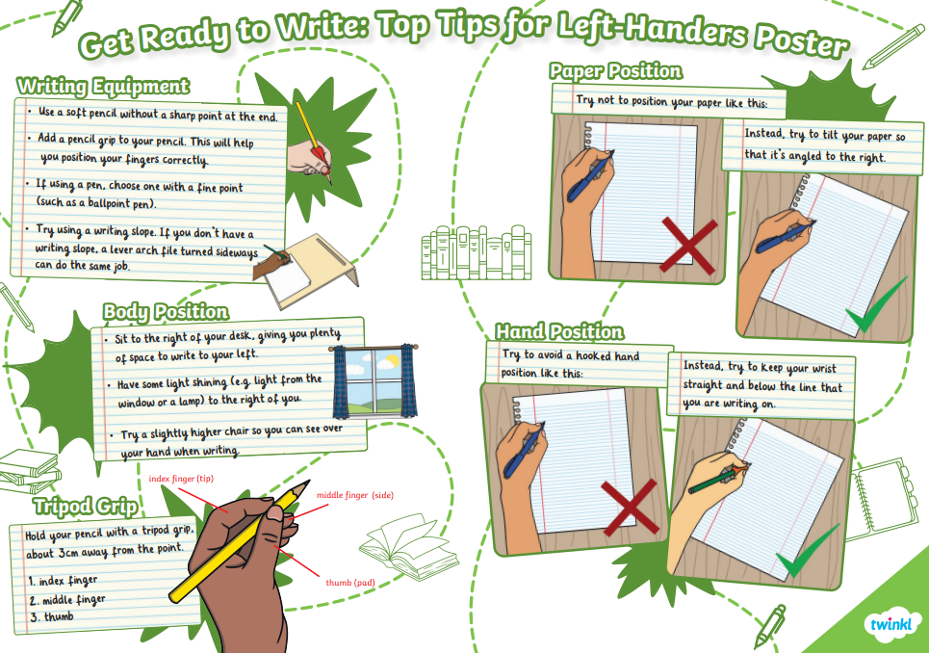

The Four Stages
We teach children to read and write Set 1 sounds from the start of Reception as part of their Read Write Inc. Phonics lessons. Children first learn to form letters while they learn to read Set 1 letter-sounds in Reception. As soon as they can read Set 1 sounds, we teach a separate daily 10-minute handwriting lesson. These handwriting lessons are at a different time from the Read Write Inc. lesson.
Stage 1 begins as soon as most children can read Set 1 sounds. We continue to teach children to form letters correctly.
Stage 2 begins during Year 1. Children learn the relative size of letters and to form letters that will flow easily into a joined style.
There is also a focus on the teaching of capital letters and digits.
Stage 3 follows straight on. Children learn how to join letters using two basic joins – the ‘bridge’ join, the ‘hill’ join and the three variations on each.
Stage 4 helps children develop a mature and speedy style.
Each stage ensures pupils meet the National Curriculum requirements for handwriting from Reception to Year 4.

Handwriting Stage 1
We start teaching separate handwriting lessons as soon as children can read Set 1 sounds.
We now teach letters in handwriting families.
Each family has a common formation.
a d g o c q
u y
b p
h n m r
e s f i
l t k j
v w x z
Children continue to write on plain paper.
Stage 1: The lesson plan- Blueprint lesson plan
Practice the letters in the handwriting order (later on in this document). Use the following routine for every lesson (this is an example lesson for the letter a):
Use the following routine for every lesson:
- Use MTYT to say the handwriting phrase: Round the apple, down the leaf.
- TOL as you use the checklist below to write the letter on the board. For example:
  - ✓ start at the stalk
  - ✓ go round the apple
  - ✓ go back up to the stalk, then down
  - ✓ curl the leaf at the bottom
Ask the children to say the checklist with you as you write the letter a few times.
Children practise writing the letter
- Check that the children are still sitting in the perfect handwriting position – above.
- Rub out the picture and any letters from the board – the children must visualise the letter, not copy.
- Ask the children to write one letter, slowly and carefully. (Do not ask them to draw the handwriting picture.)
- Model again how you repeat writing the letter, getting a bit quicker each time.
- Go round the room supporting children who need help. Don’t sit with one child.
Review the letter
- Write the letter on the board and make one error, choosing a common error children have made.
- Ask the children to TTYP to find your ‘two best bits’, for example, you remembered to start at the stalk, and you went back up to the stalk.
- Then ask children to TTYP to find ‘one to fix’, for example, you made the leaf too curly.
- Rewrite the letter perfectly.
- Ask children to practise again.
On the next day, choose a new focus letter or review one or two previously taught letters.
Note: Help children learn to visualise the letter as a picture and not the written checklist. Do not write the checklist on the board, though you may need a sticky note to help you remember to start with.
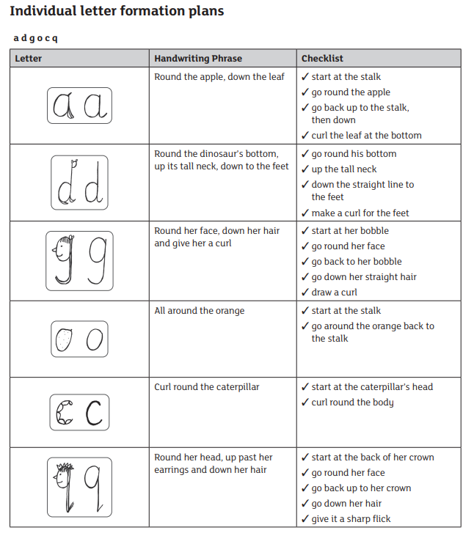

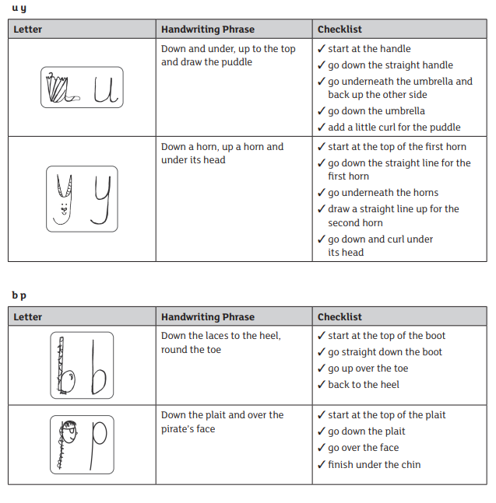

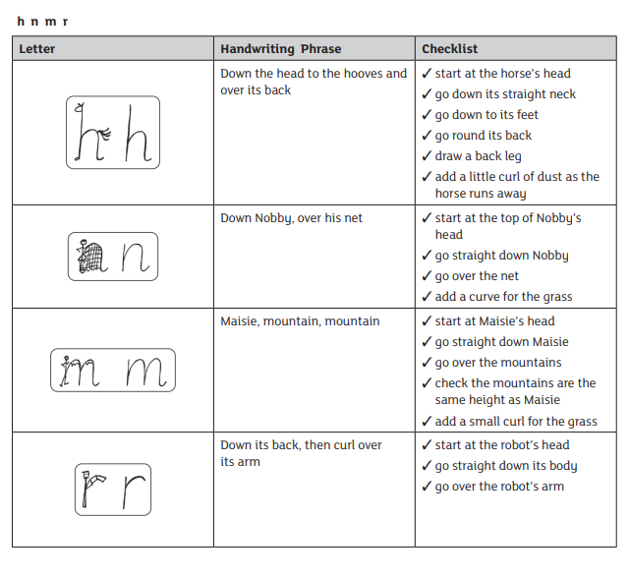

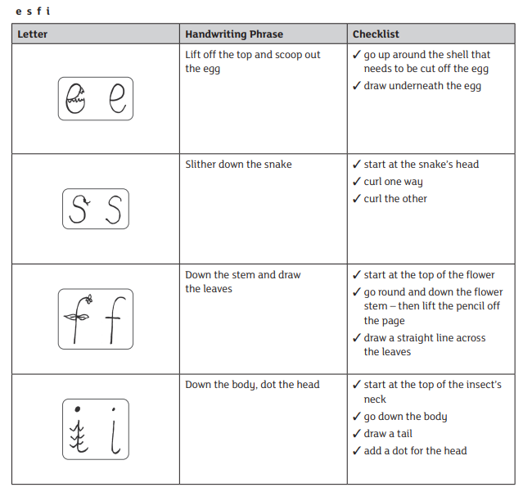

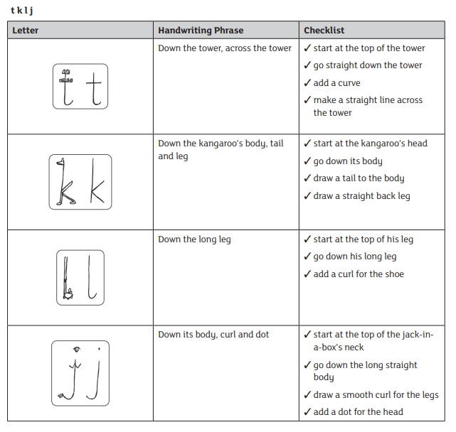

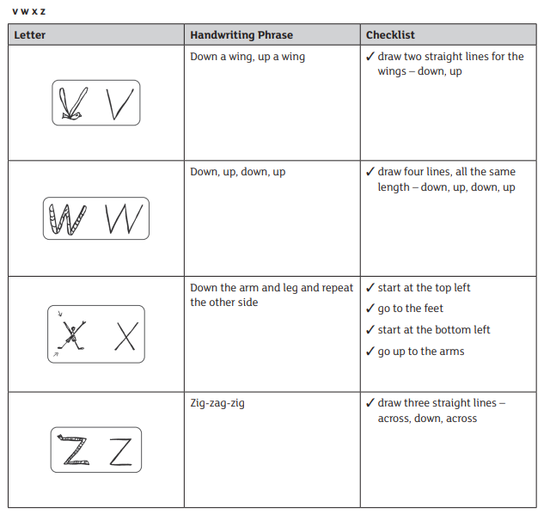

Handwriting Stage 2
The Lesson Plan – Capital Letters and Digit
Once children are secure with how to form all lower-case letters correctly, the next stage is to teach them how to form capital letters correctly. Use the yellow lines to teach the children that capital letters sit on the line and are taller than the lower-case letters. Use the capital letter formation guide to teach the children the different strokes needed to form each capital letter. Children will also learn digits.
Demonstrate
1. Display the highlighted paper for modelling
2. Show the children where to start the letter and the strokes needed to form it.
Use the guide to ensure you are modelling this correctly.
3. Remind children about the size of the capital letter.
Practice
1. Check the children are sitting the perfect handwriting position.
2. Rub out the model on the board, children must not copy.
3. Ask the children to write each letter slowly and carefully.
4. Model again how you write each letter, getting quicker each time.
5. Circulate the room praising what you see.
Review
1. Write the letter on the board, making an error.
2. Ask the children to TTYP to find two positives and one fix.
3. Rewrite the letter perfectly, correcting using the children’s feedback.
4. Ask the children to practice again.
5. Ask the children to work with a partner to find two positives and one thing to
fix in their own work.
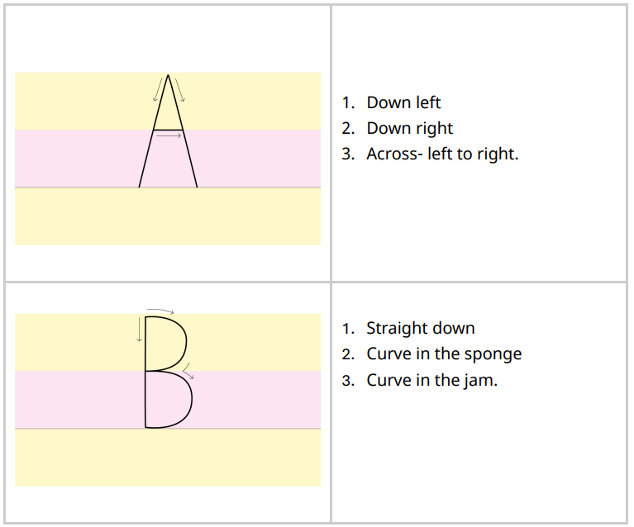 | 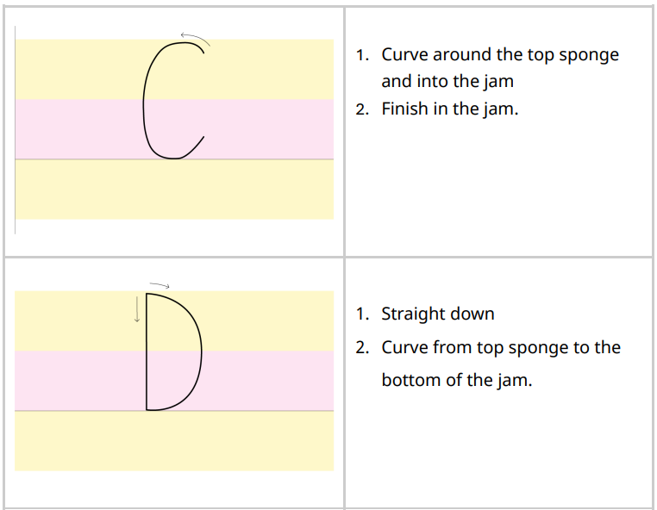
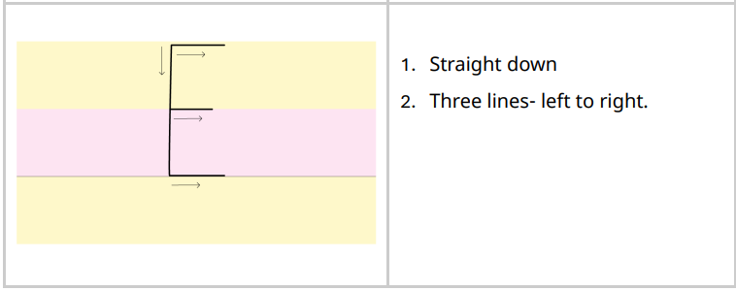  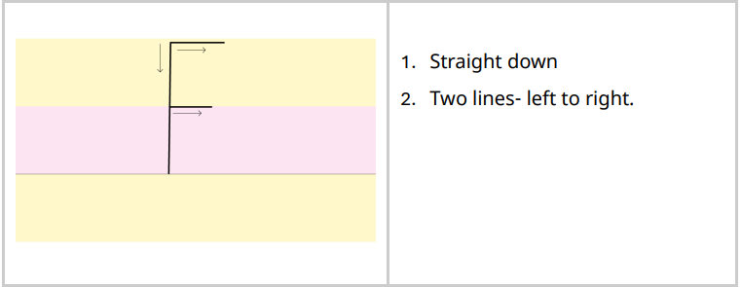 | 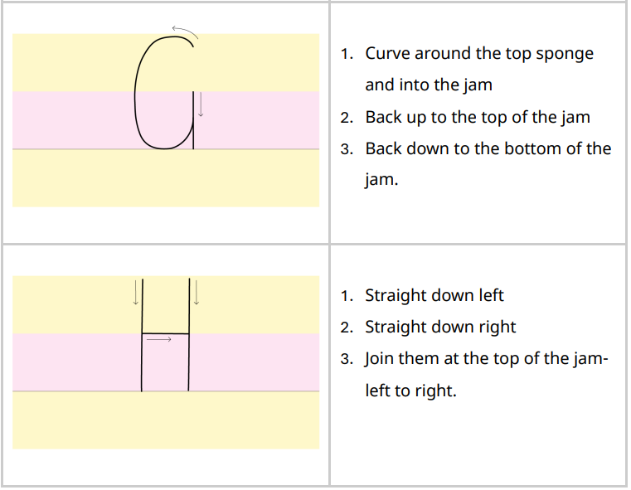
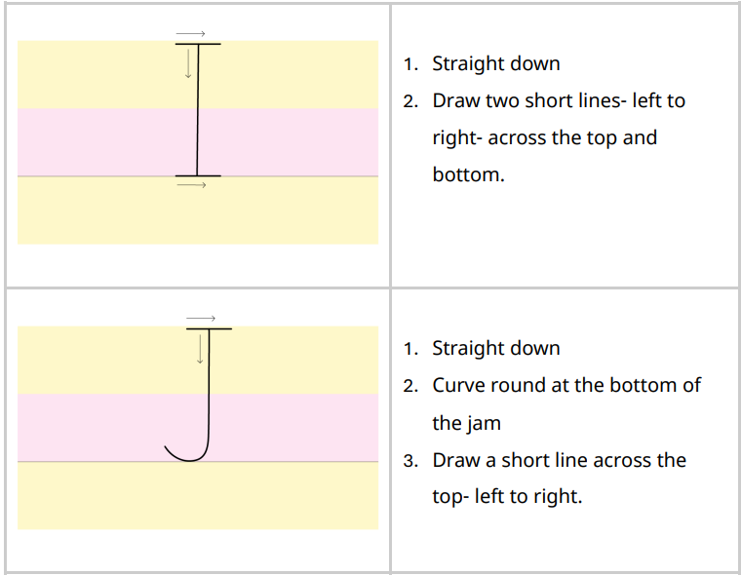 | 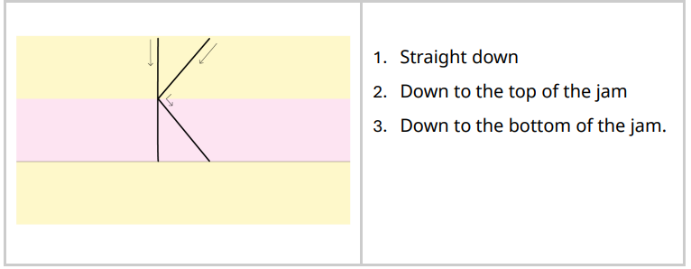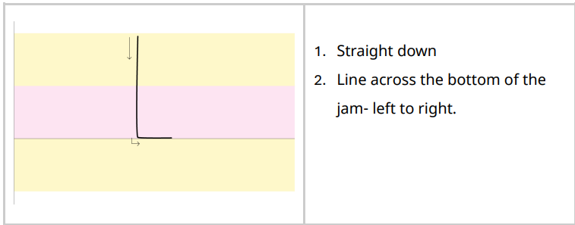
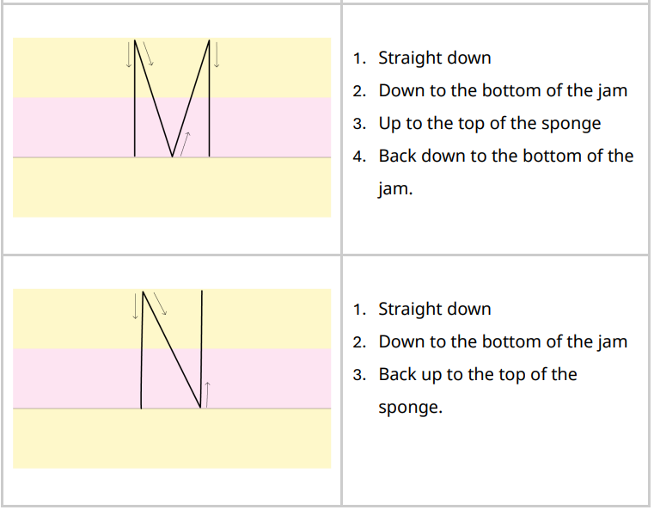 | 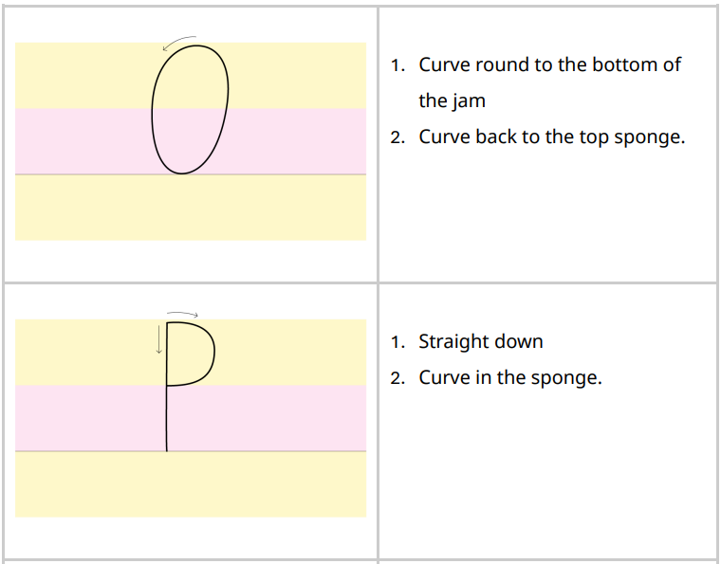
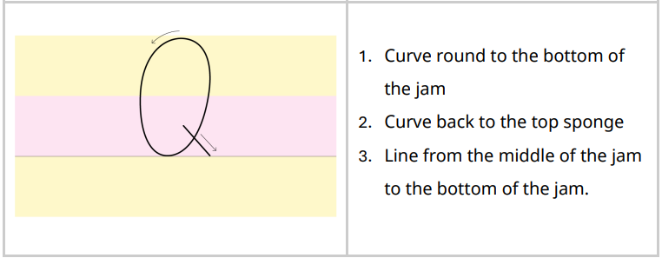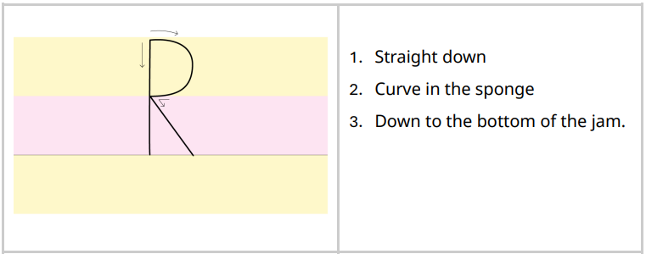 | 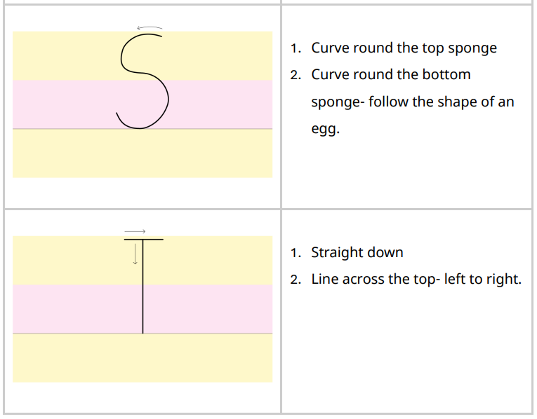
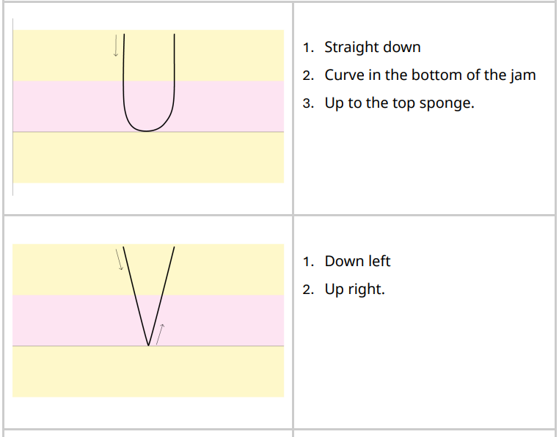 | 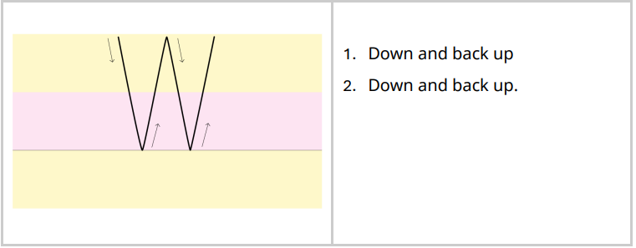  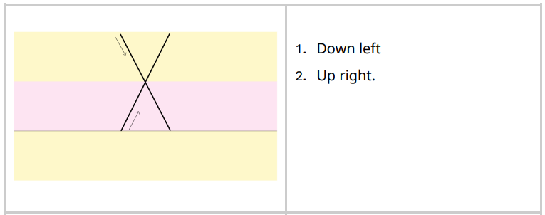
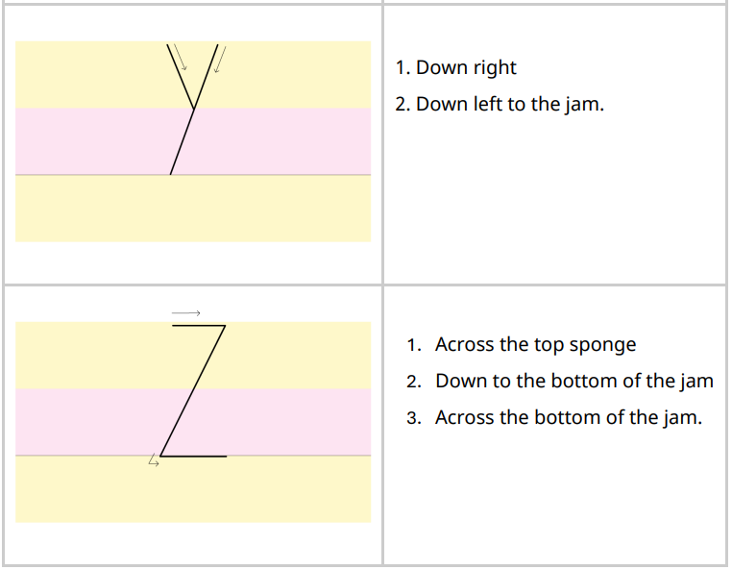

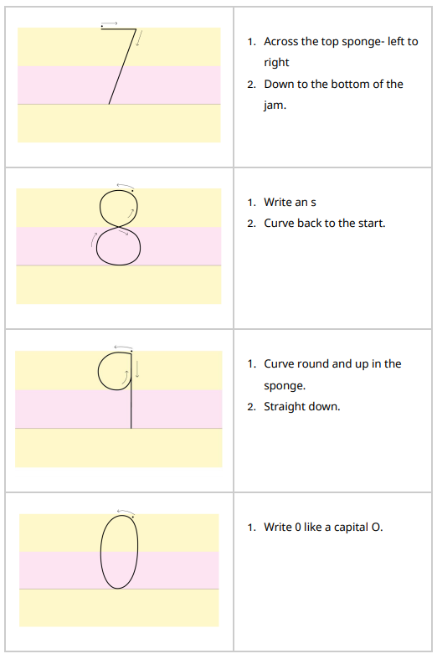
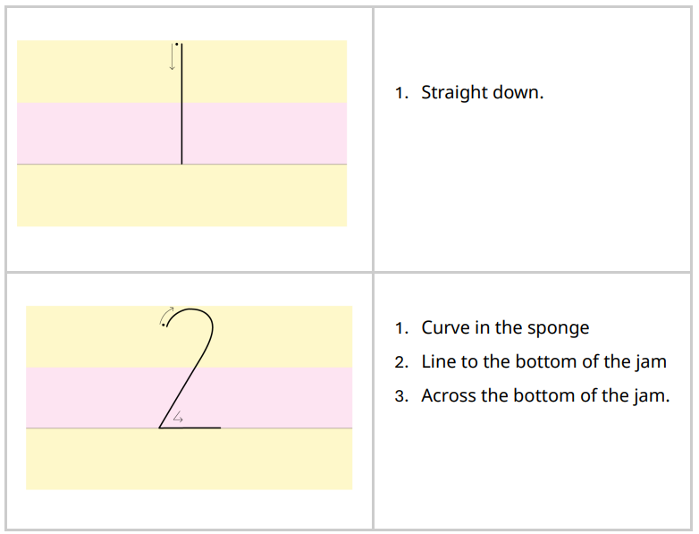
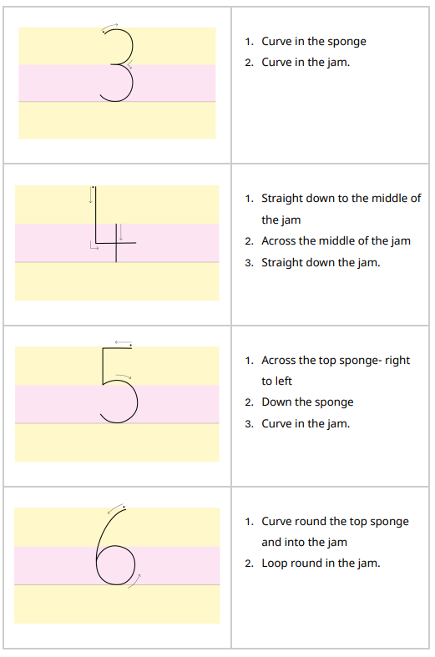

At Stage 2, we now group letters that have a similar formation:
a d g o c q
u y
b p
h n m r
e s f i
l t k j
v w x z
These new handwriting ‘picture hooks’ focus on each group’s shared similarities. For example, here’s the first group of letters – a d g o c q. You can see that the shape of all six sisters’ heads is identical – except for their hair.
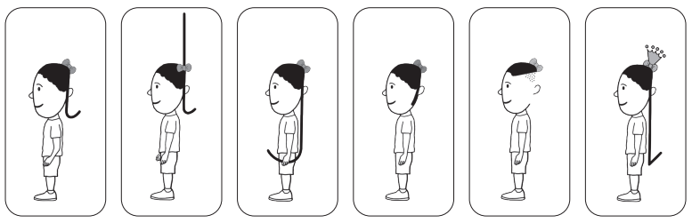
Introduce the formation family: six sisters, two uncles and their two pets. The six sisters – Annie, Dina, Gabi, Olivia, Carina and Queenie – all look the same. Their mother tells them that they must all have a different haircut so people can tell them apart!
The uncles – Uncle Umberto and Uncle Yaseen – look just like the sisters, except they are bald on the top of their heads.
The family have a dog and a bunny whose faces are very similar too, but they have long ears.

Stage 2 FILM - Blueprint lesson plan (DAY 1)
Each film follows the same structure:
- Introduce the story with a letter and a rap.
- Show children how to write the letter.
- Children practise writing the letter.
- Children check their letters with their partner.
- Repeat steps 2, 3 and 4.
- Review the new letter and previous letters by asking children to practise writing words containing them.
While your children are writing, support children who need extra help.
Stage 2 teacher modelling- Blueprint lesson plan (DAY 2)
This is an example lesson for the letter d.
Demonstrate
1. TOL as you use your mental checklist to write the letter d.
✓ start at her hair bobble on top of her head
✓ all the way over the top of her head
✓ curve down her face
✓ round chin
✓ join the chin by her ear
✓ up to the bobble
✓ straight tall spiky hair – up and down
✓ curve at the line and draw small flick (not curvy)
Repeat a few times using MTYT.
2. Ask the children to TTYP to say the mental checklist.
3. Take feedback.
4. Ask two partners to tell you how to write the letter d.
Repeat a couple more times until the children can say the mental checklist to each other.
Practice
1. Use the handwriting signal to check that the children are still sitting in the perfect handwriting position. 2. Rub out the picture and any letters from the board – the children must not copy.
3. Ask the children to write one letter, slowly and carefully. (Do not ask them to draw the handwriting picture.)
4. Model again how you repeat writing the letter, getting a bit quicker each time.
5. Go round the room praising what you see so others can hear. Don’t sit with one child. For example: “Nice round chin there! Love the long straight hair. What a great curl.”
Review
1. Write the letter on the board and make one error, drawing on children’s common errors.
2. Ask the children to TTYP to find your ‘two best bits’, for example, you remembered to start at the bobble. Then ask the children to TTYP to find ‘one to fix’.
3. Rewrite the letter perfectly, correcting using children’s feedback.
4. Ask children to practise again.
5. Ask children to find ‘two best bits’ and ‘one to fix’ in each other’s work.
On the next day, independent practice, and review one or two previously taught letters. Ensure target support on identified children. (DAY 3)
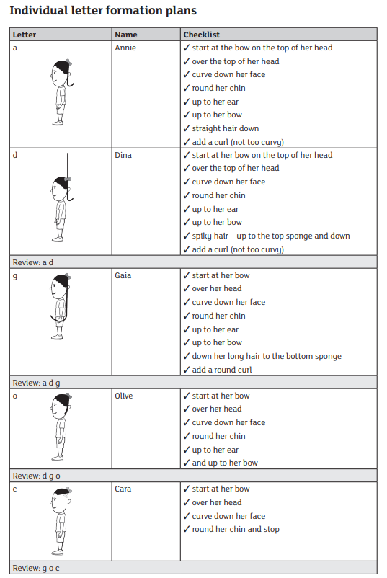
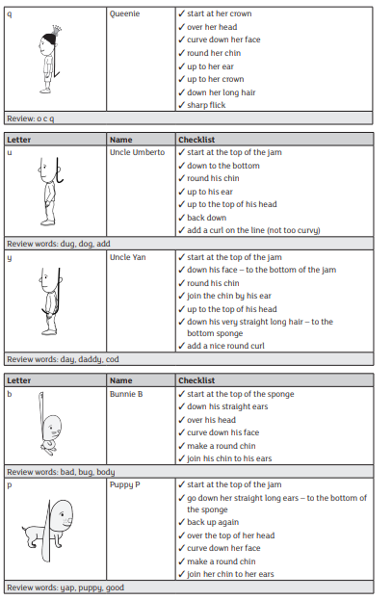
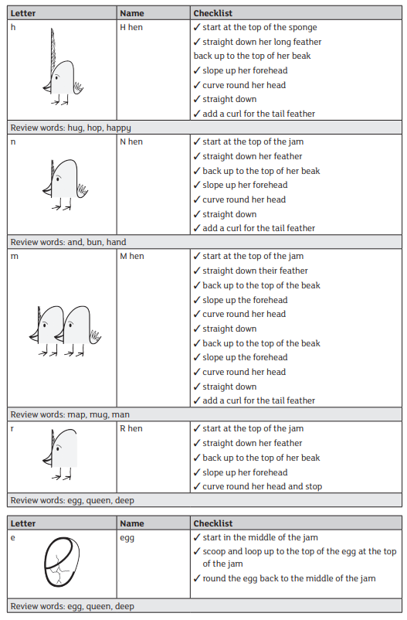
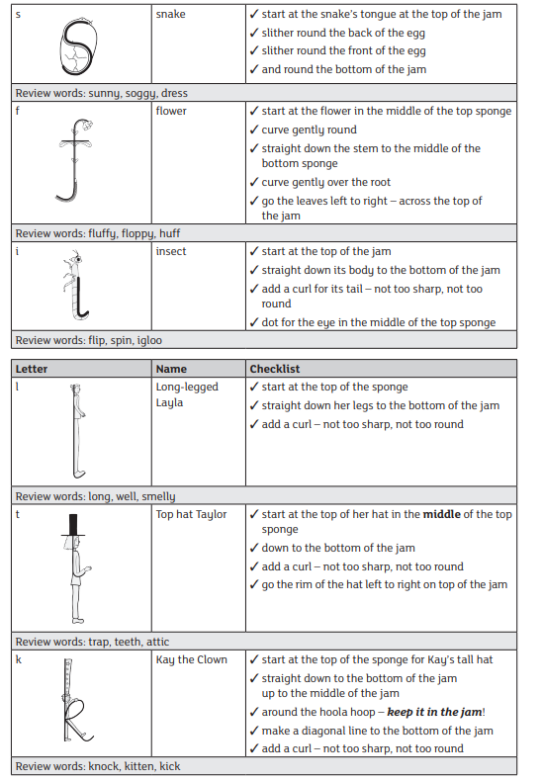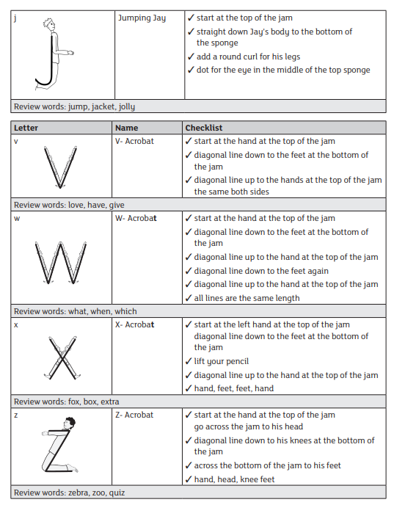
Handwriting Stage 3
Children return to Letter Village for Stage 3. They will learn two joins: the ‘hill’ join and the ‘bridge’ join. There are three variations of both joins:
Explain to the children that there are two basic joins:
- The hill join (diagonal)
- The bridge join (horizontal)
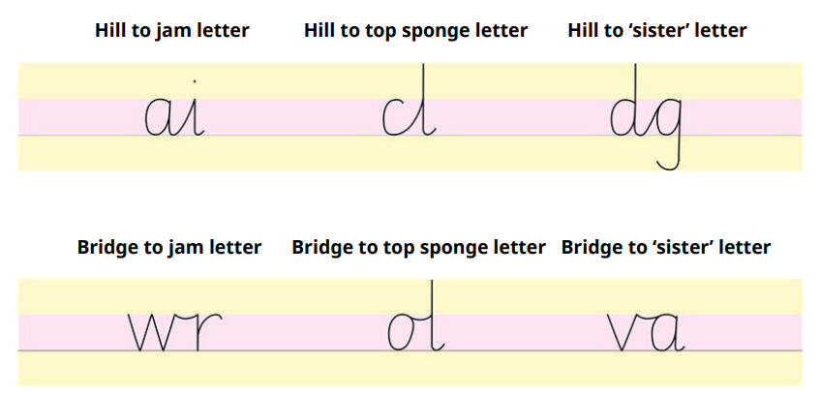
Children practise each join with specific letter combinations. Then they write words with the joins they have practised.
We teach children that all letters are joined with the ‘hill’ or ‘bridge’ join with the exception of g, j, q, y and z:
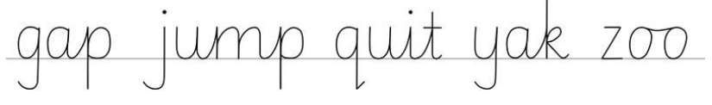
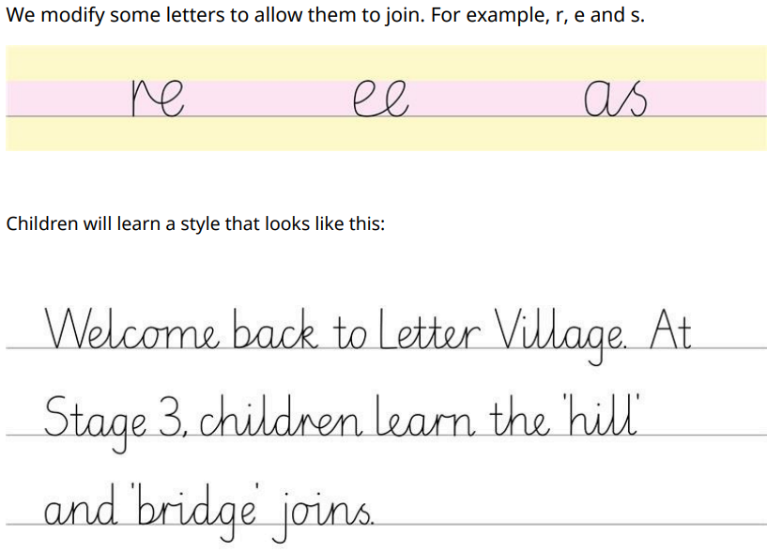

Stage 3 FILM- Blueprint lesson plan (DAY 1)
Each 10-minute film follows the same structure
- Introduce the join with a story and a rap.
- Show children how to join two letters.
- Children practise writing two letters with the join.
- Children check their letter joins with their partner.
Repeat steps 2, 3 and 4.

Every fourth film is a ‘celebration’ lesson: children practise writing words that contain all the joins they have learnt following the same structure.

Stage 3 teacher modelling- Blueprint lesson plan (DAY 2)
Demonstrate
- Demonstrate how to write the letters.
• TOL about where to start a – level with the top of the jam. Recall the checklist for Annie as you write the letter.
• TOL as you write the join – not too spiky, not too round, not too squeezed, not too spaced.
• TOL as you write i. Recall the checklist for i.
- Ask children to TTYP: What size is each letter? What is good about your join?
- Take feedback.

Practice
- Use the handwriting signal to check that the children are still sitting in the perfect handwriting position.
- Rub out the joined letters from the board – the children must not copy.
- Ask the children to write each letter and the join, slowly and carefully.
- Model again how you repeat writing the letters and join, getting a bit quicker each time.
- Go round the room praising what you see so others can hear. Don’t sit with one child. For example: “I love the spacing of your join and the join is not too spiky or too round.”

Review
- Write the letters and join on the board and make one error, drawing on children’s common errors.
- Ask the children to TTYP to find your ‘two best bits’. Then ask them to TTYP to find ‘one to fix’.
- Rewrite the letters and join perfectly, correcting using children’s feedback.
- Ask the children to practise again.
- Now ask them to find ‘two best bits’ and ‘one to fix’ in each other’s work.

On the next day, independent practice, and review one or two previously taught joins. Ensure target support on identified children. (DAY 3)

Stage 3 Joining Plan
Hill to Jam Letter
1. 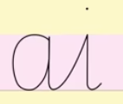 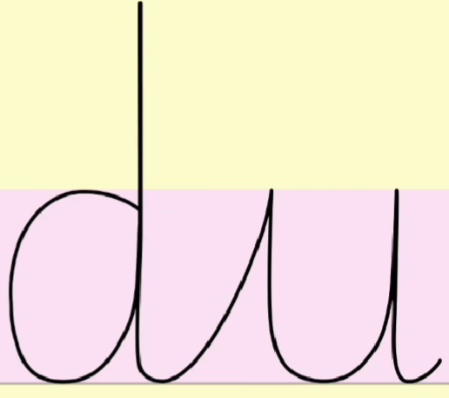 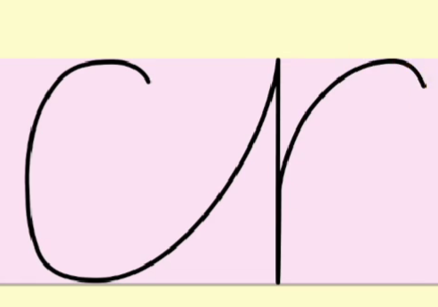
2. 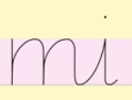 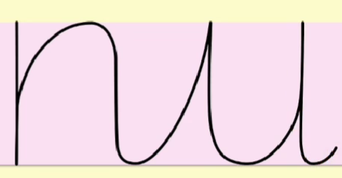 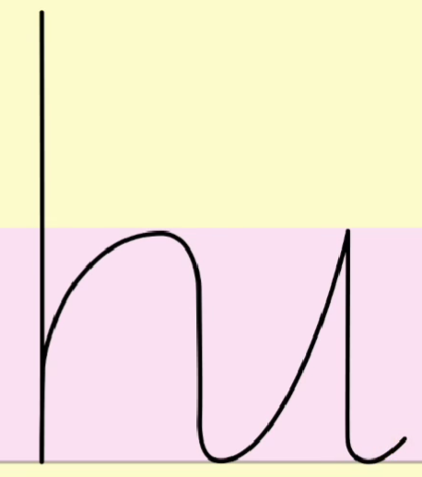
3. 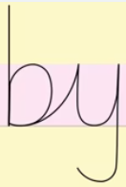 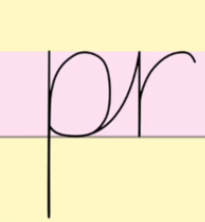 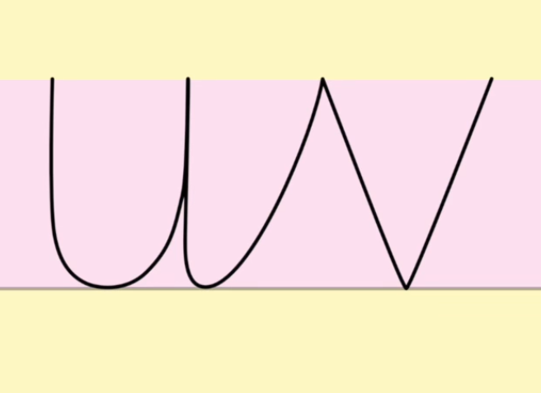
4. 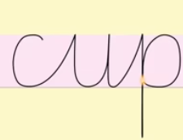 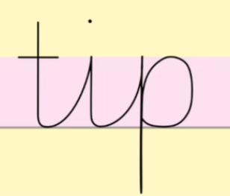 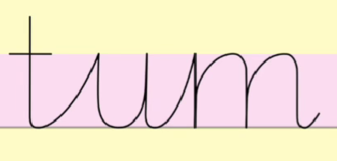 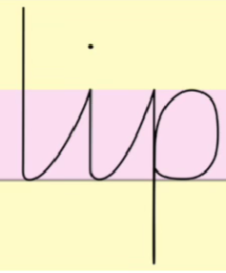 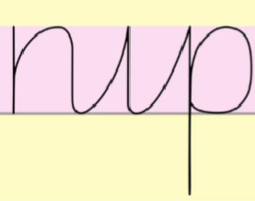

Hill to Top Sponge Letter
- 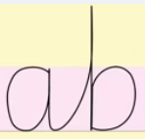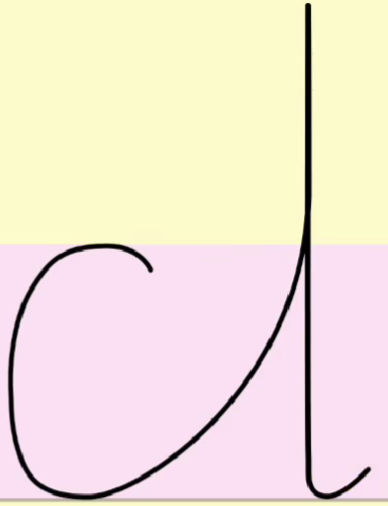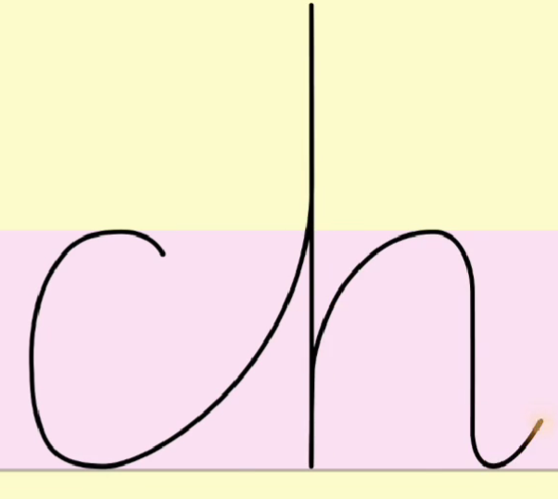
- 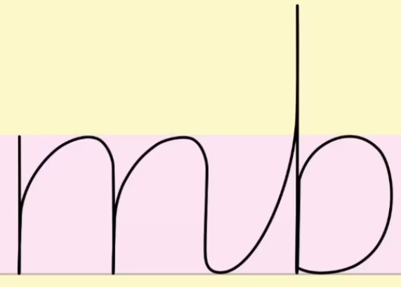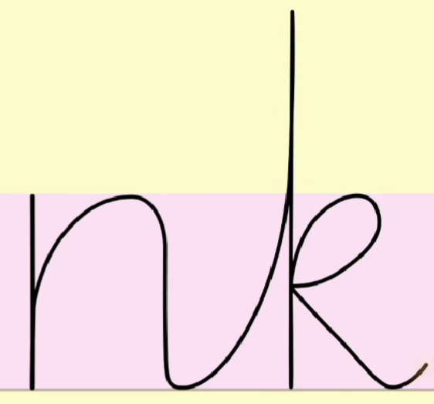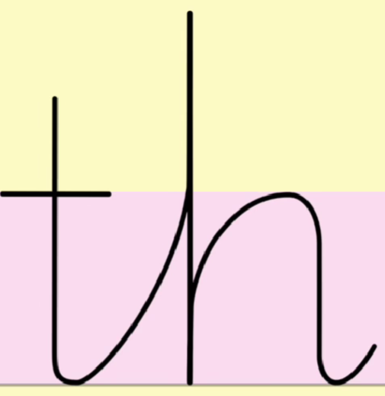
- 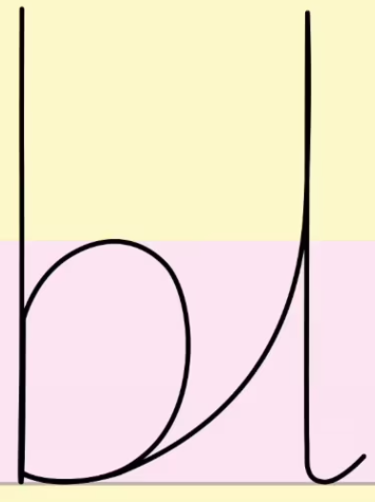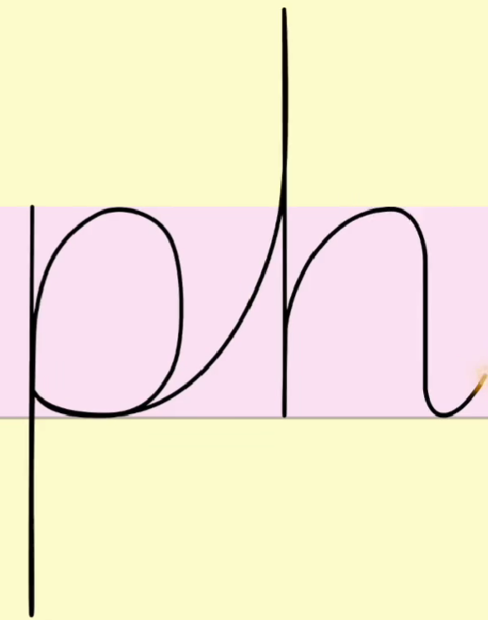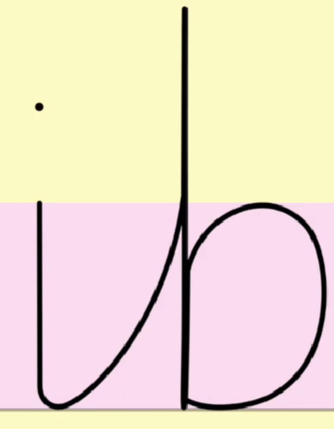
- 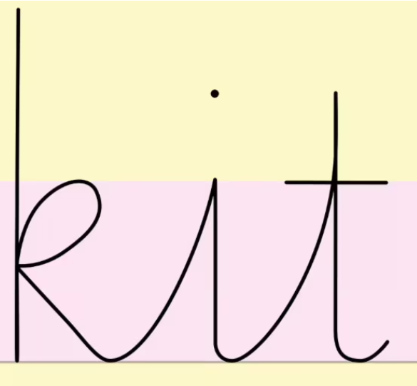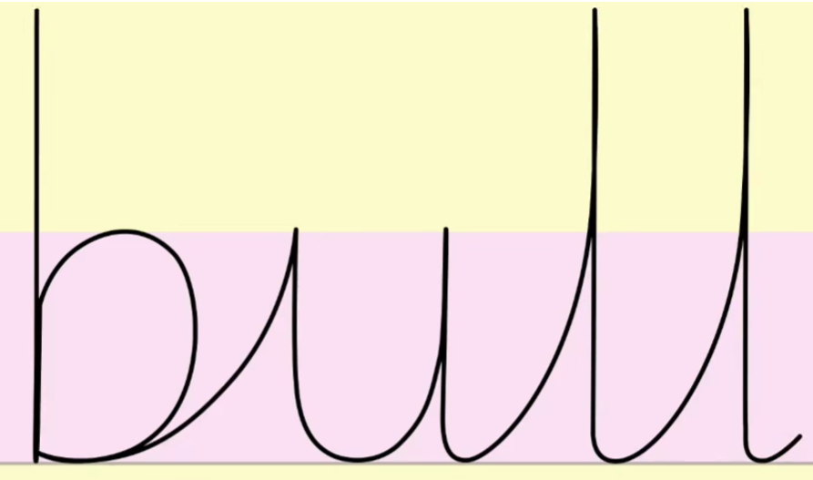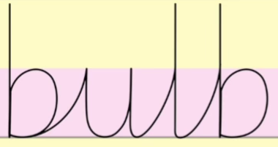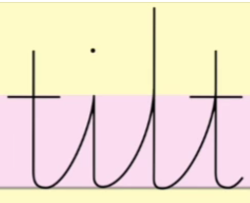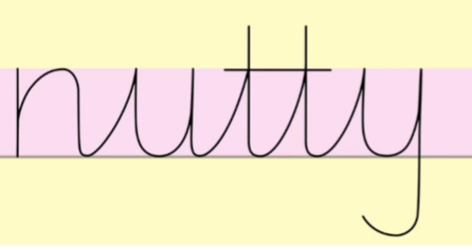

Hill to Sister Letter
1. 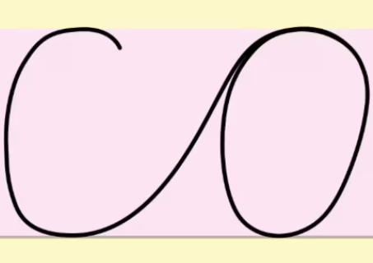 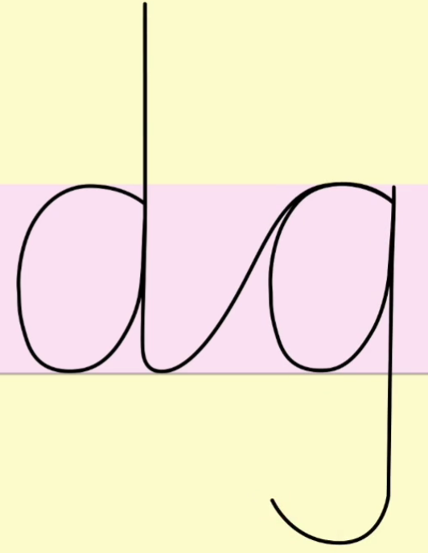 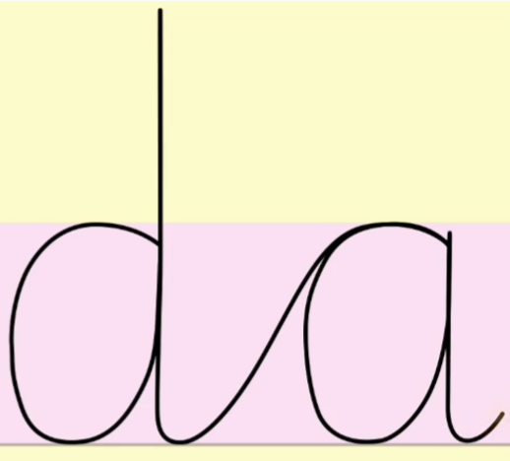
2.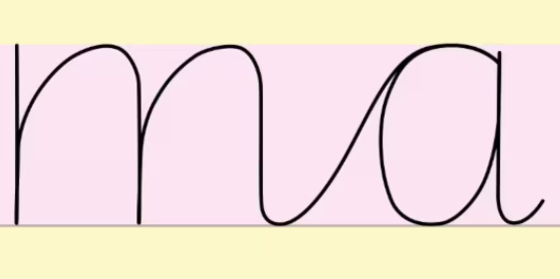 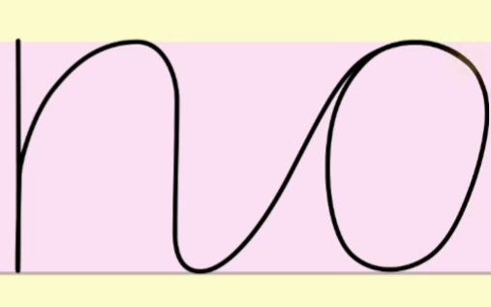 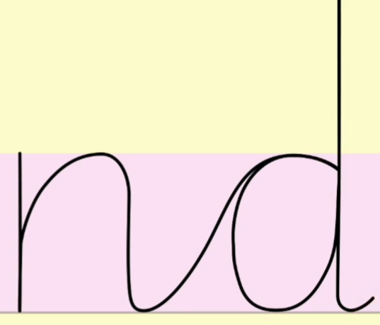
3. 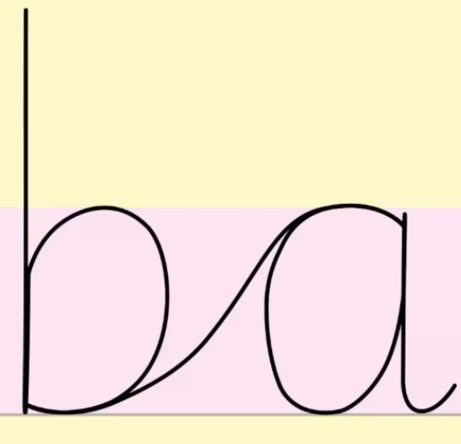 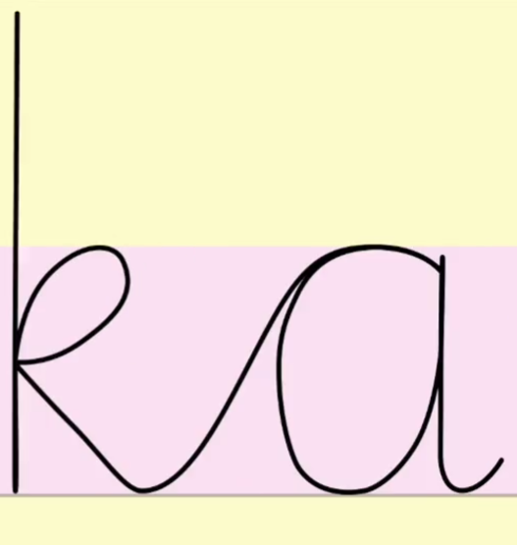 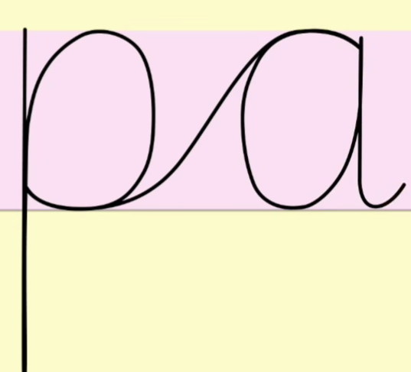
4. 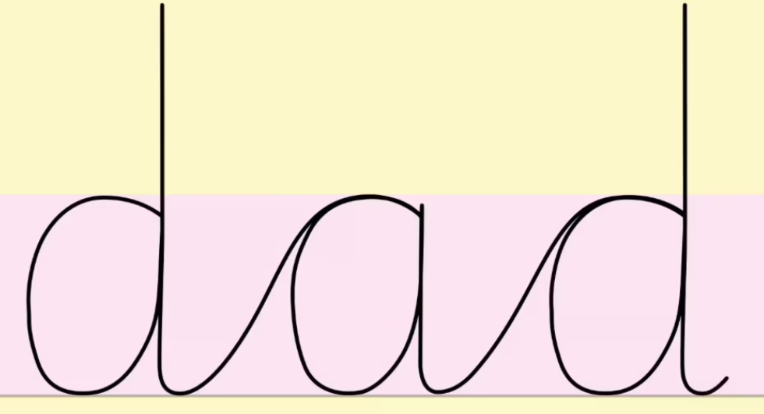 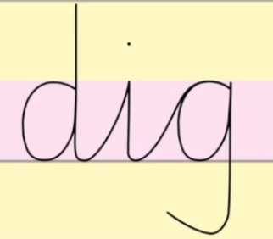 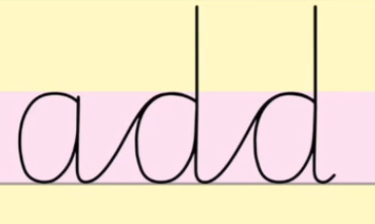 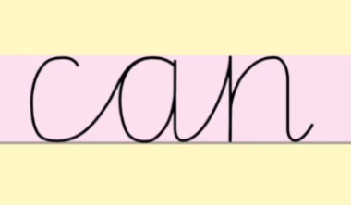 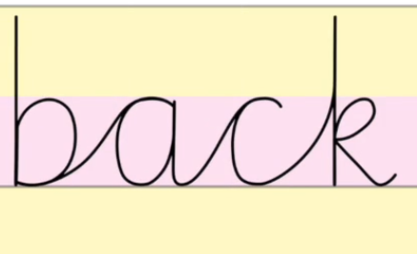
Bridge to Jam Letter
1. 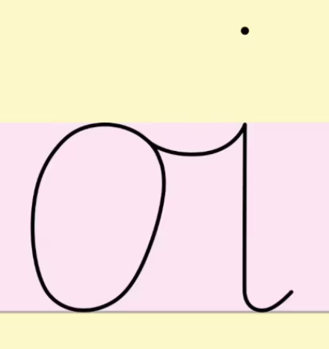 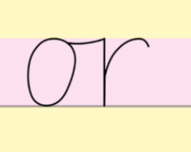 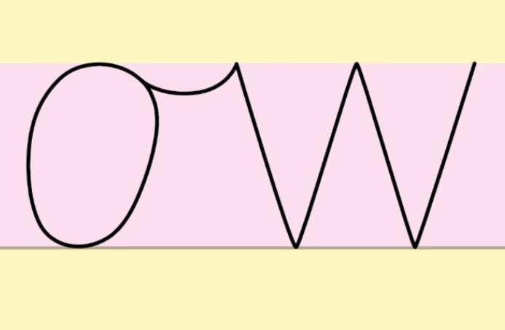
2. 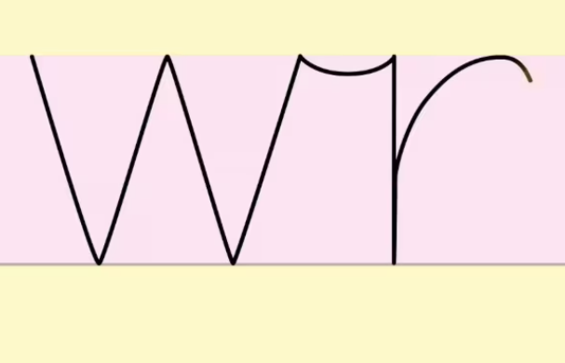 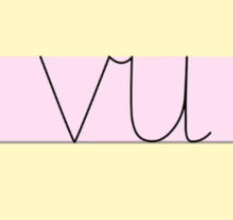 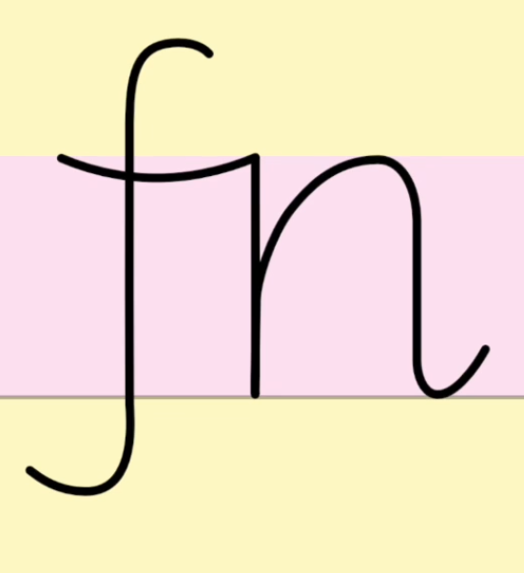
3. 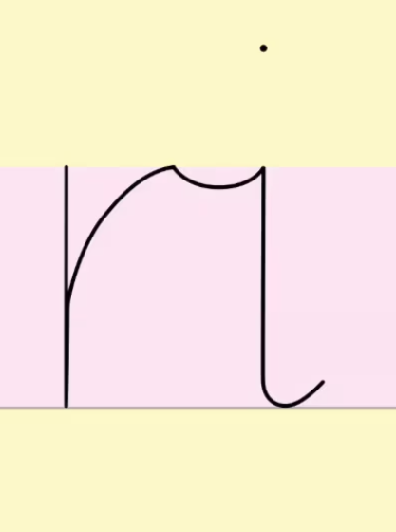 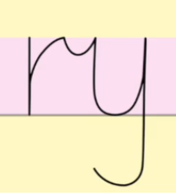 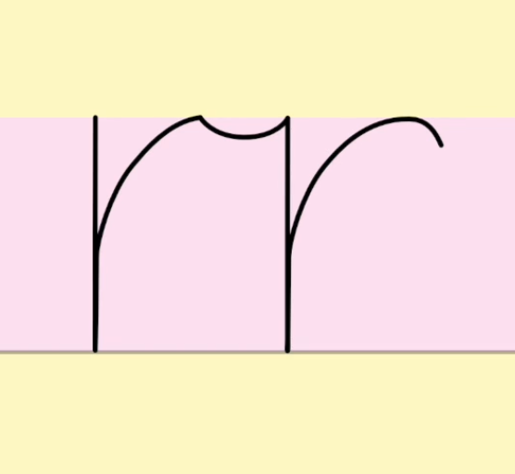
4. 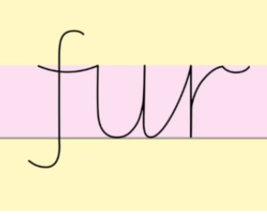 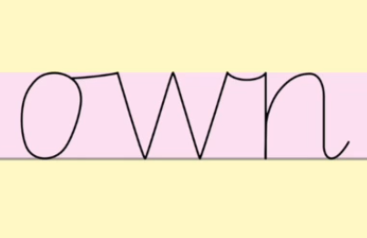 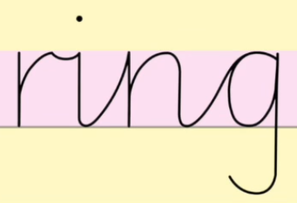 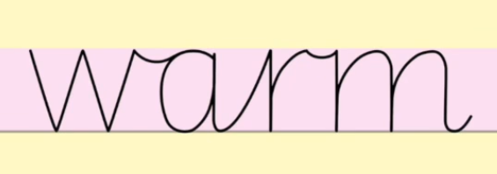 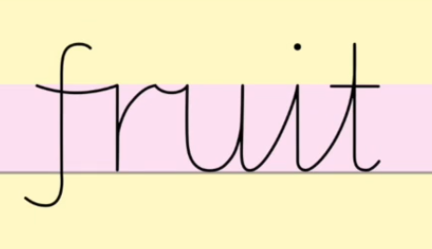
Bridge to Top Sponge Letter
1. 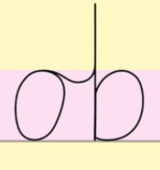 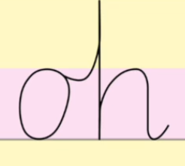 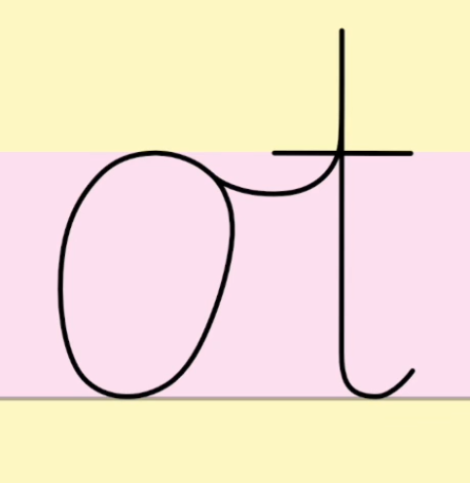
2. 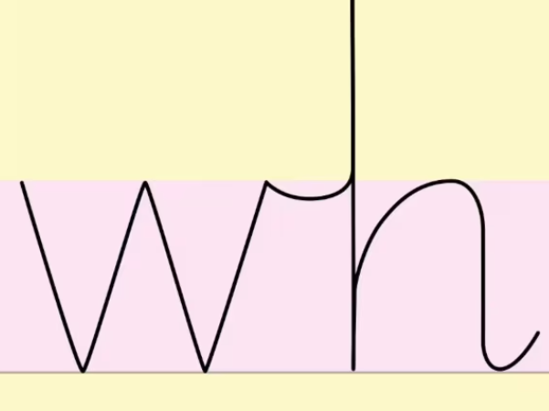 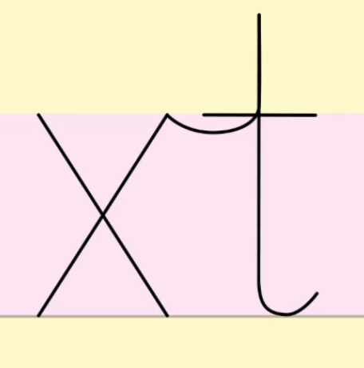 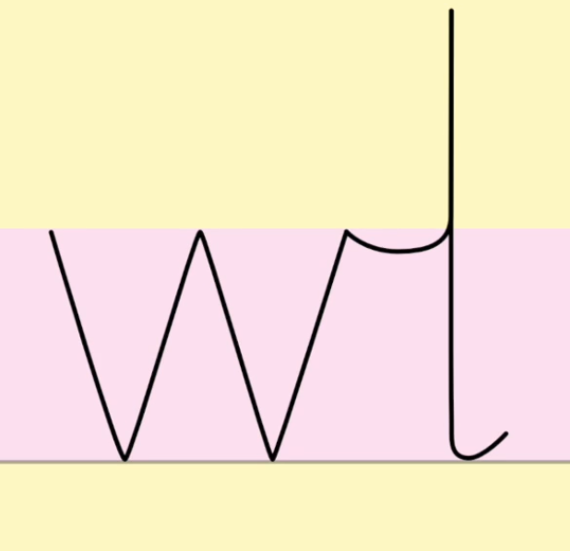
3. 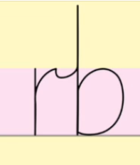 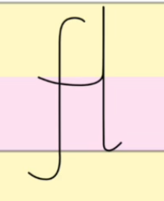 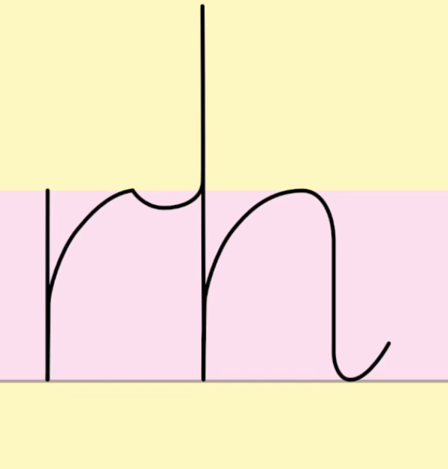
4. 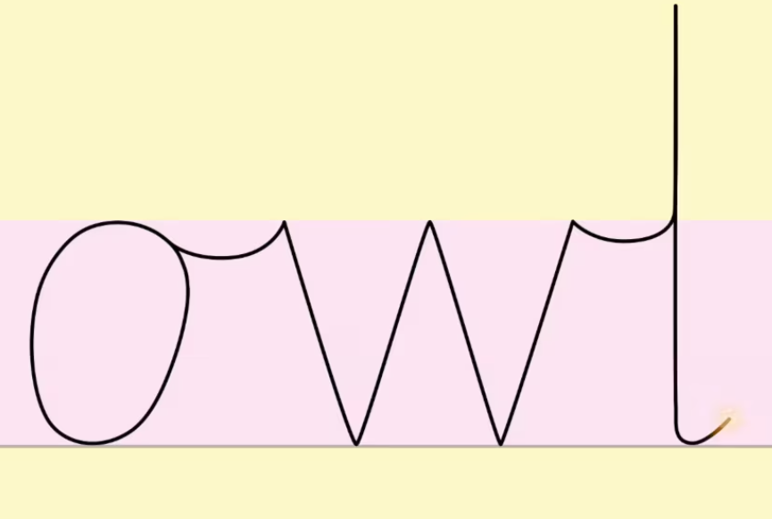 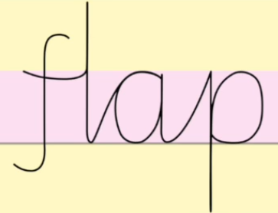 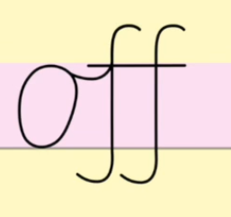 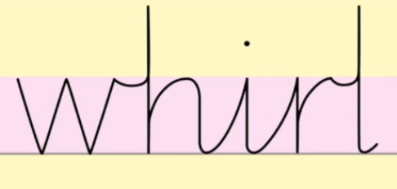 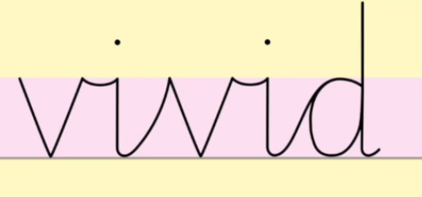

Handwriting Stage 4 - TBC Coming in Spring 1

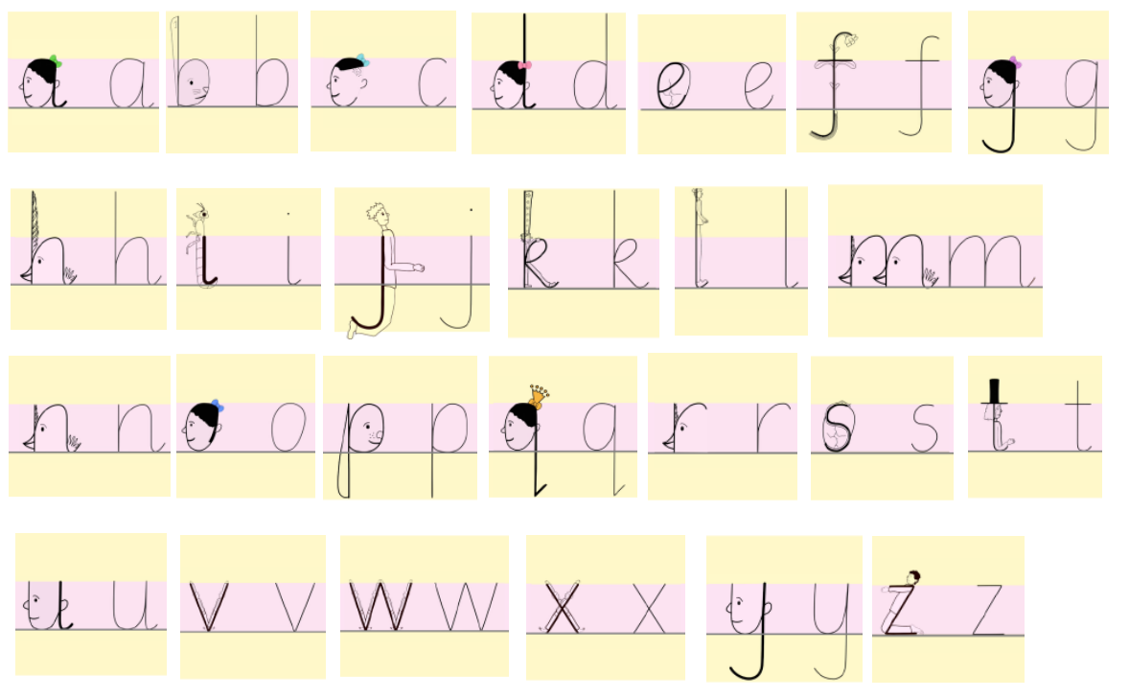

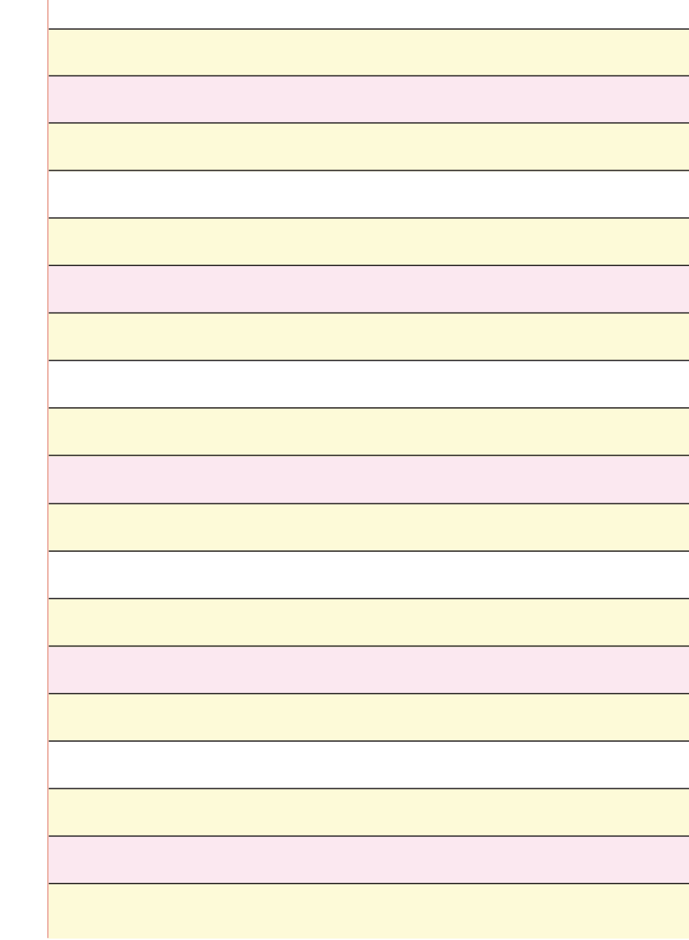
Appendix 1 – Handwriting guidelines

