Writing Strategy – Newtown Primary
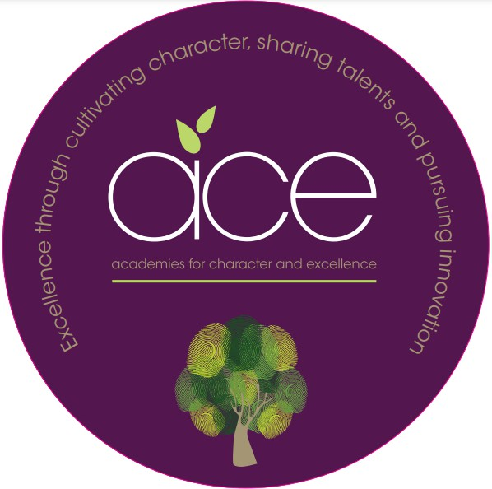
At Newtown alongside reading, writing is at the heart of the curriculum. At Newtown our English curriculum promotes high standards of language and literacy by placing a strong emphasis on reading, writing and oracy. Our intent is to inspire all children to be passionate and successful writers.
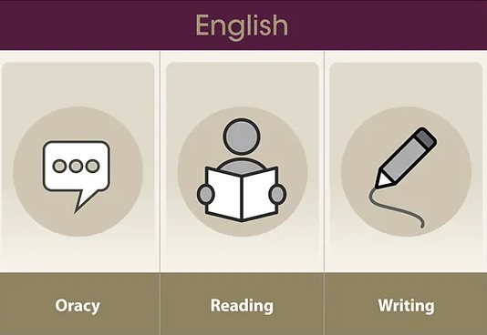

All children at Newtown begin their writing journey in our preschool. As all children move up through the school they become more knowledgeable about the different reasons in which people are motivated to write - to teach, persuade or influence, entertain, paint with words, reflect and to make a record.
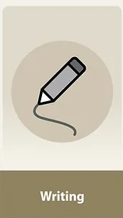

As a school we follow the ACE Writing Progression document. This document explains that in all year groups, we teach writing through our high-quality learning experiences We use texts and experiences such as: picture books, novel studies, immersive sensory experiences and real-life experiences from visits in and out of school to respond to an enquiry question. In addition, writing links are made to other subject areas within the curriculum.
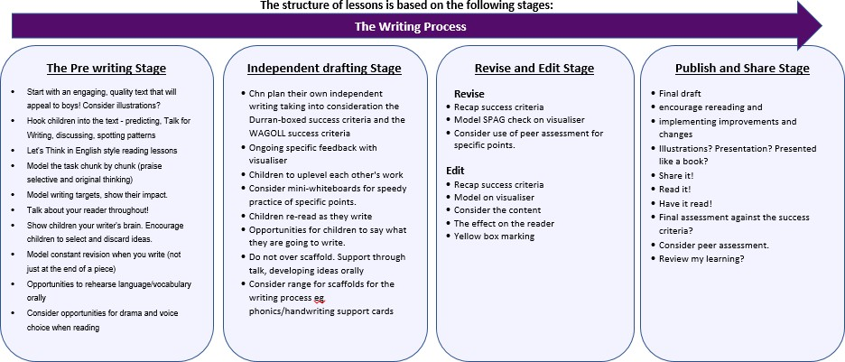
Our writing progression document outlines the end of year outcomes for all children. This is structured and organised into the following headings:
- Letter formation/handwriting
- Planning, Drafting and Editing
- Audience, Purpose and Structure
- Sentence Structure - including punctuation and grammar

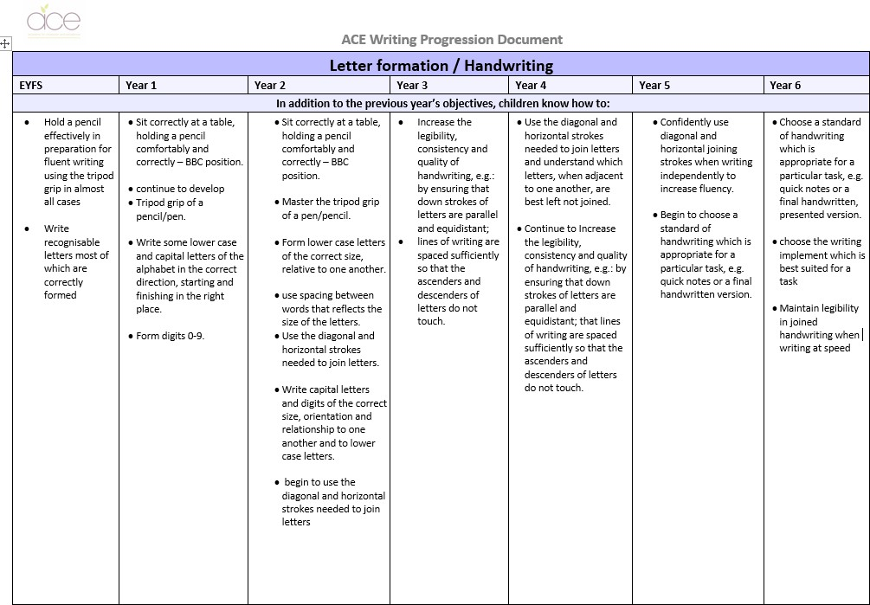
Here are two examples:

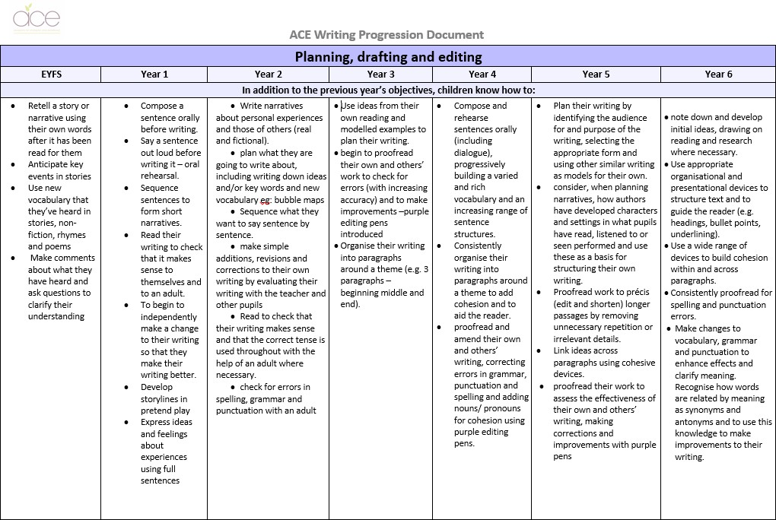

Know, Show and Grow:

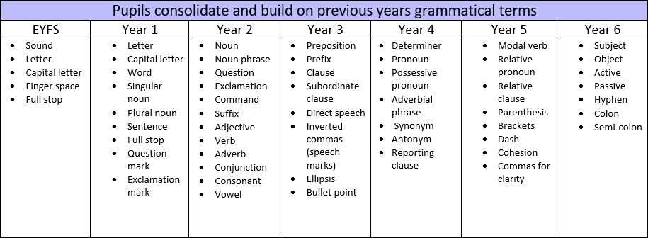
Grammatical terms are built upon each year. This knowledge is progressive and is constantly revisited at the point of writing within the ‘Know’ and ‘Show’ stage of a writing enquiry or if writing is a supporting subject then throughout this enquiry. Children are also expected to demonstrate their secure knowledge of these grammatical features within the ‘Grow’ stage. Teachers plan for opportunities for the children to grow as learners promoting independence, creativity and collaboration.
As children move up through the school new writing expectations are introduced. Children are expected to
include all previous year group expectations within their writing. For example - Year 3 writing expectations (must include all of KS1 expectations). Year 5 writing expectations (must include all of KS1, Y3 and Y4).

Target Setting:

All children have individual writing targets so that they are aware of what their next steps are at the point of writing. These are continuously reviewed by teachers and support staff and new targets are set moving learning forward at the earliest point. From the Early Years we encourage our children to view the writing process as a whole. This metacognitive tool enables all children to value the importance of planning and reviewing as well as the ‘task completion’ aspect of writing.
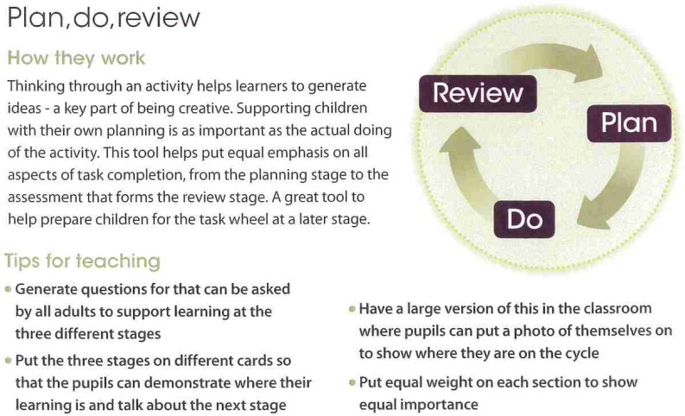

Target Setting and Metacognition in KS2:

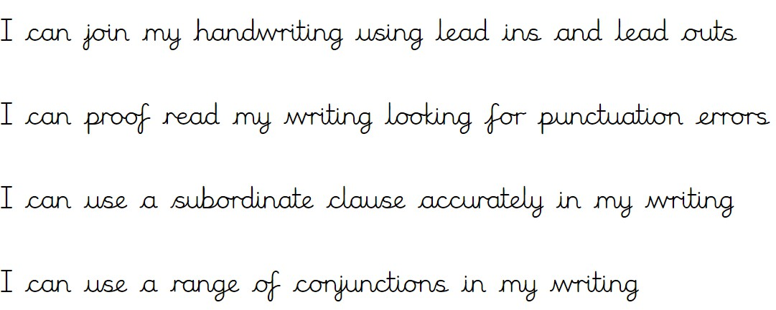
In KS2 children are able to think more maturely about the challenges they set themselves. This metacognition tool enables all learners to think independently and set themselves achievable and smart targets.
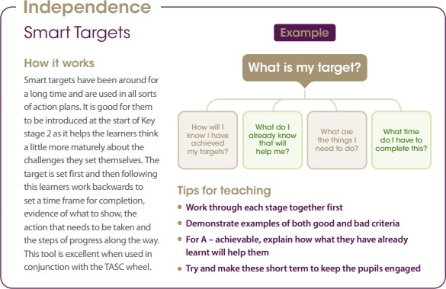

Example Targets (Y3):

Writing in Lower School
Gateways:

Character Development in Writing:

Our gateways for learning are our vehicle for developing character. Children are expected to practise and develop traits. At Newtown we recognise the importance of this to achieve high quality outcomes in writing.

Within our Exploration gateway for example we develop the children’s courage to take on challenges through being aspirational and resilient. In writing children are taught to:

- Pick themselves up when a piece of writing needs improving, editing in purple pen, showing resilience
- Knowing not to dwell on the negatives but to look at the positives too by highlighting in green individual strengths within their own piece of writing or the writing of a peer

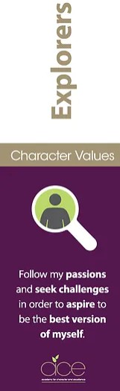

Reflective Questions and the Writing Process:

Reflections are a key component of the writing process from the Early Year - Year 6. Both writing and reflections are highly personal and are happening continually within the classroom. Sometimes reflections can be formal and written down, or informal, this is when it is purely thought about.

As a writer, self reflections help you to think about your own skills and understand where improvements might be made to improve the overall outcome of your text. Children are expected to think about audience, purpose and structure as well as letter formation, handwriting and vocabulary choices.
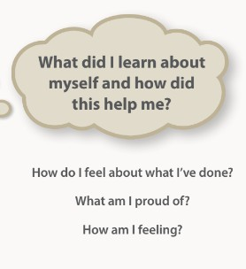
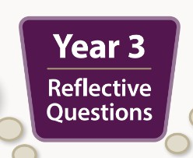

Spelling:

At Newtown we have a separate spelling strategy which follows the ACE writing progression document. A range of resources are used including the Oxford Owl RWI approach to the teaching of spelling. Children often revisit their spellings in early morning tasks or at the beginning of an enquiry lesson. If a spelling is corrected in green by an adult, children revisit this word three times in purple underneath and transfer this spelling to their personal spelling list. Dedicated curriculum time is also allocated to the teaching and practise of the YR3/4 statutory word list and the YR5/6 statutory word list.

Here is an example from our the Newtown Spelling Strategy:
